Unit 1: Daily life and shopping lesson 16 |  | School:№34 «Birlik»
Date:03.10.23y |  | Teacher name:
Grade: 8 «Ә» |  | Number present: | absent:
Lesson title | Language focus:  Present perfect: regular and irregular verbs
Learning objectives | 8.1.6.1 organise and present information clearly to others  8.6.7.1 use a variety of simple perfect forms to express recent, indefinite and unfinished past on a range of familiar general and curricular topics  8.2.3.1 understand with little or no support most of the detail of an argument in extended talk on a wide range of general and curricular topics
Lesson objectives | Learners will be able to:  • Learn regular and irregular past participles.  • Identify use of the present perfect in a conversation.  • Practise using the present perfect in a discussion.
Value links | Thoughtfulness – You may highly value people who are thoughtful. If this is you, then you might find yourself rolling your eyes at people who are full of bluster and never stop to reflect on their own actions.
Plan
Stages / Time | Teachers’ actions | Students’ actions | Assessment criteria | Resources
Start | Organization moment  1.Greeting.  Ask about the weather.  Divided into two groups  1st group ‘Regular verbs’  2nd group ‘Irregular verbs’  What was your hometask?  Warm-up  • Refer students back to the language focus section on page 29 and ask how we form the past participle of most verbs.  • Elicit that for regular verbs such as the ones on page 29, the past participle is the same as the past simple form: we add -ed to the verb.  • Elicit examples of some irregular verbs. Explain that some verbs also have irregular past participles.  Lead - In  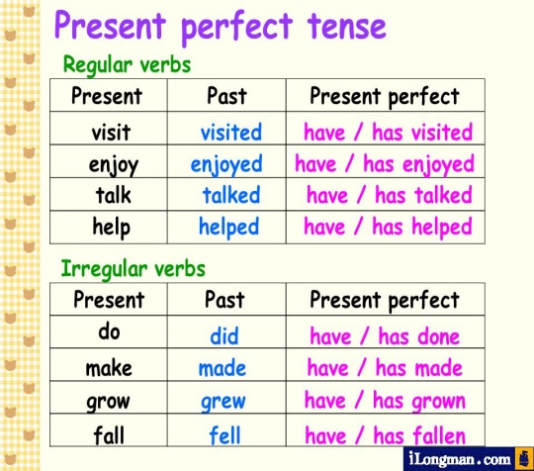 | “The wish flower” method helps to start the lesson with good wishes to each other.  The aim: To develop Ss speaking skills and create friendly atmosphere  Efficiency: By wishing each other they feel better and feel the support of others.  Students introduce themselves  Students say different words from the picture | At the organization moment T tries to award active Ss.«The praise» method is used to evaluate Ss with phrases like:  “Good job!  Well done!”  Formative Assessment    Good job!  Assessment criteria  -Learn vocabulary about pollution |       laptop  Student’s book
Main part | Individual work  Task: 1 p:23  • Once students have completed the table individually, ask them to check their answers in pairs. If students are not sure whether a verb is regular or irregular, tell them to check in their Irregular Verb list or a dictionary.  • After students have checked their answers in the text, ask individual students to read out their answers  Who can't manage on his/her//their  own?  LOW achievers students (Zulpybek M, Rakhmatullaev N)  Write the correct past participles.  For example have -had  1. begin 2 .join  3. meet 4. drink  5. spend 6.speak  7. recognize 8. feel  Task 2 p:23  • Students add the verbs to the table from exercise 1. Again, refer them to Irregular Verb list or a dictionary if they need help with the irregular forms. In a weaker class, you could write the irregular verbs on the board in alphabetical order, to help them find the correct past participles.  You'll have to finish in a minute.  Finish off now.  Your time is up now.  Pair work  1.Kate and Bill (find) …………….a new flat.  2.Nick (write) ……. a book.  3.We (decide)…….to start jogging.  4.Sam and Dave (eat) …………..all the sandwiches  LISTENING  Group Work Method ‘Poster’  Ex: 3 p:23  • Tell students they are going to listen to a conversation about three people’s internet usage.  • Play the CD twice. The first time, students should listen and see how much they can understand. The second time they listen, they can complete the table  • Check answers by copying the table on the board and asking students to come up and complete the rows.  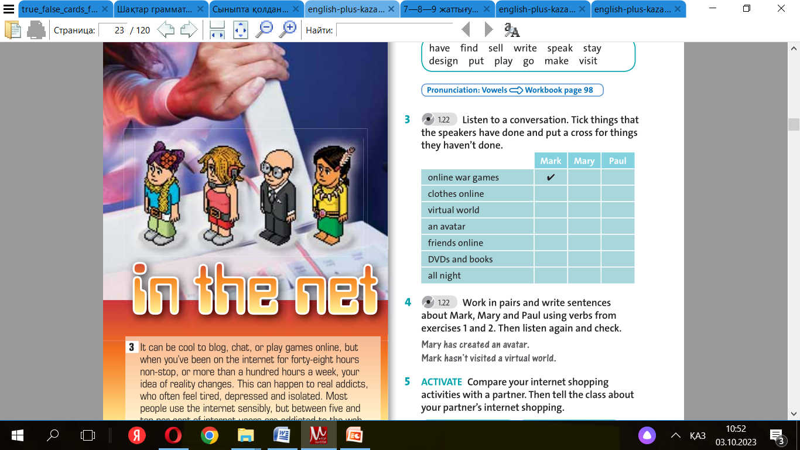  INDIVIDUAL WORK  Method ‘Wordwall’  - Descriptor: Learners must answer correctly each question | Students complete the table with the past participle form of the verbs in the box.  Descriptor:  Regular: join – joined, ruin – ruined  Irregular: buy – bought, sleep – slept, eat – eaten, be – been, spend – spent  Descriptor:  1.begun 2.joined  3.met 4drunk  5.spent 6.spoken  7.recognized 8.felt  Students add the verbs in the box to the table  Descriptor:  Regular: stay – stayed, design – designed, play – played, visit – visited Irregular: have – had, find – found, sell – sold, write – written, speak – spoken, put – put, go – been/gone, make – made  Student listen to a conversation. Tick things that the speakers have done and put a cross for things they haven’t done  ANSWERS:  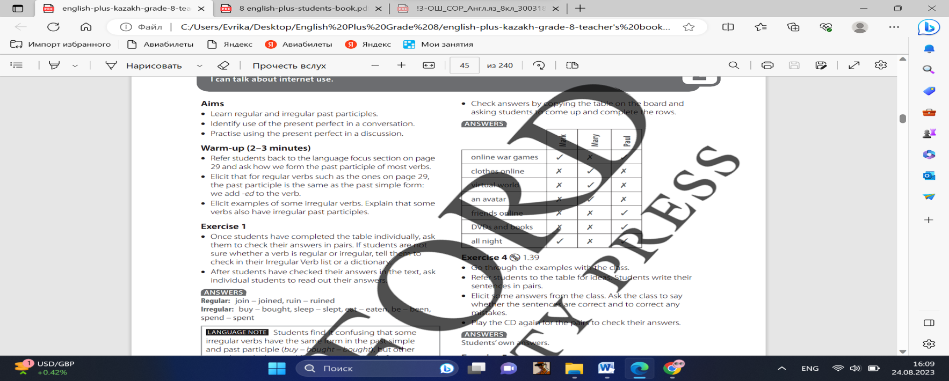  Students work in pairs and write sentences about Mark, Mary and Paul using verbs from ex. 1 and 2. Then listen again and check  ANSWERS:  Students’ own answers  https://wordwall.net/ru/resource/61371582 | Descriptor:  -complete the table  Total: 1point  Differentiation: Modelling- teacher gives clear description of the task with examples  Descriptor:  -add the verbs in the box  Total: 1point  -Make CCQ questions  Yes / No  Descriptor:  -work in pairs and write sentences  Total: 1point | Cards  Worksheets
End | Home task: Remember your homework.  Ex: 3 P: 17 Workbook |  |  | Poster  Laptop

Тексерілді: 03.10.23ж

